1. Install botkit facebook - <https://github.com/howdyai/botkit/blob/master/docs/readme.md#installation>

2. Create Facebook bot page - https://www.facebook.com/pages/create/  
 1. Choose tab – Brand or Product  
 2. Chose – App Page.

2. Create or use your facebook developer account and create Messenger Platform app.   
 <https://developers.facebook.com>

3. Generate a page access token for your app in your Developer Account.  
 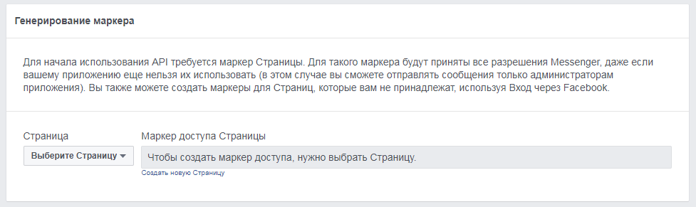  
4. Define your own "verify token" - this is a string that you control that Facebook will use to verify your web hook endpoint. Example – “testbot” or etc.  
5. Set up a webhook endpoint for your app that uses your public URL , set verify token  
 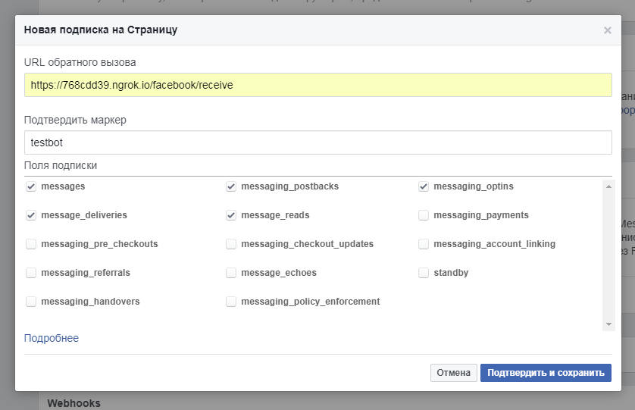  
 Webhook url shouldn’t be localhost. You must deploy your project in Heroku (production). Or create tunnel for your localhost.  
 Don’t forget subscribe to bot page after confirming webhook.  
6. You should pass your page access token and verify token in .env file of your botkit project.

More documentation: <https://developers.facebook.com/docs/messenger-platform/introduction>  
BotKit getting-started: <https://github.com/howdyai/botkit/blob/master/docs/readme-facebook.md#getting-started>

**Chat extension**

Steps for adding chat extension:  
1. You should create your simple web-view app.

2. Add in your index.html this script:  
(function(d, s, id){

var js, fjs = d.getElementsByTagName(s)[0];

if (d.getElementById(id)) {return;}

js = d.createElement(s); js.id = id;

js.src = "//connect.facebook.com/en_US/messenger.Extensions.js";

fjs.parentNode.insertBefore(js, fjs);

}(document, 'script', 'Messenger'));

3. Set config for extension:  
 controller.api.messenger_profile.domain_whitelist(['https://768cdd39.ngrok.io/', 'https://lorempixel.com/']);

controller.api.messenger_profile.home_url({

url: 'https://768cdd39.ngrok.io/',

webview_height_ratio: 'tall',

in_test: false

});

<https://developers.facebook.com/docs/messenger-platform/webview>